Lab Practical #07:
Study the application layer protocol DNS, DHCP, FTP.
Practical Assignment #07:
- Implement the application layer protocol DNS, DHCP, and FTP. Also check connectivity between them using ping command or PDU utility.
- DNS
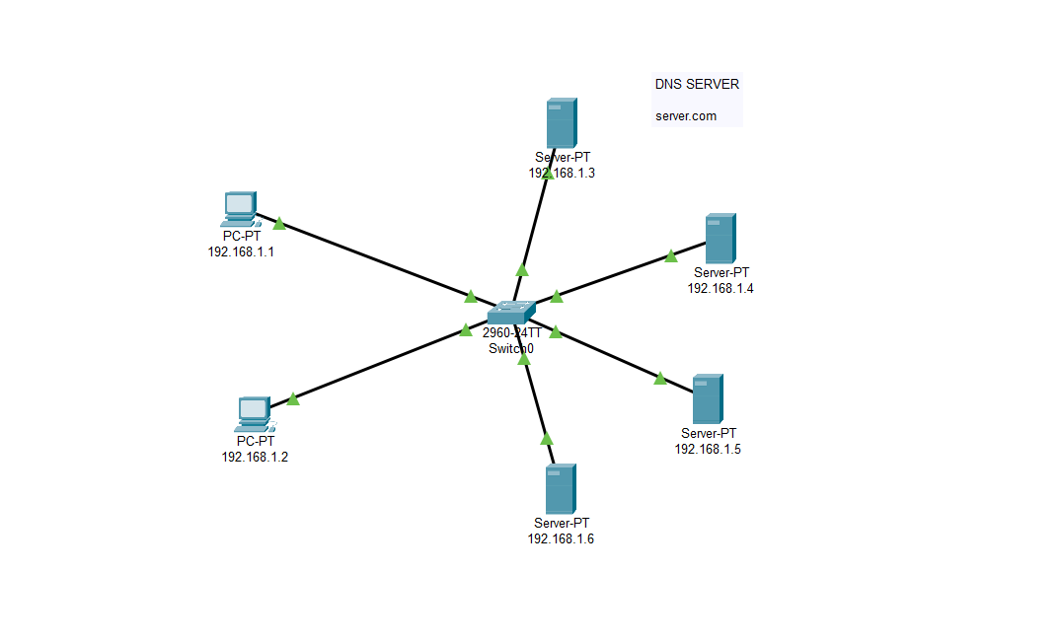
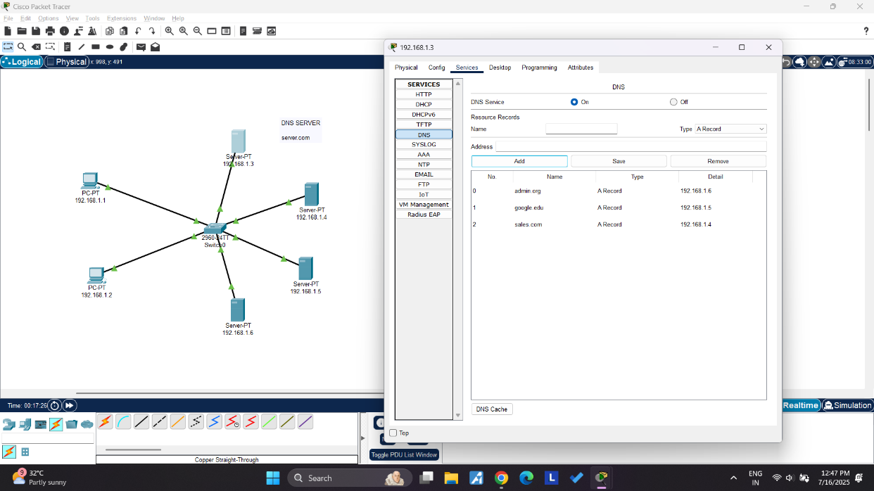

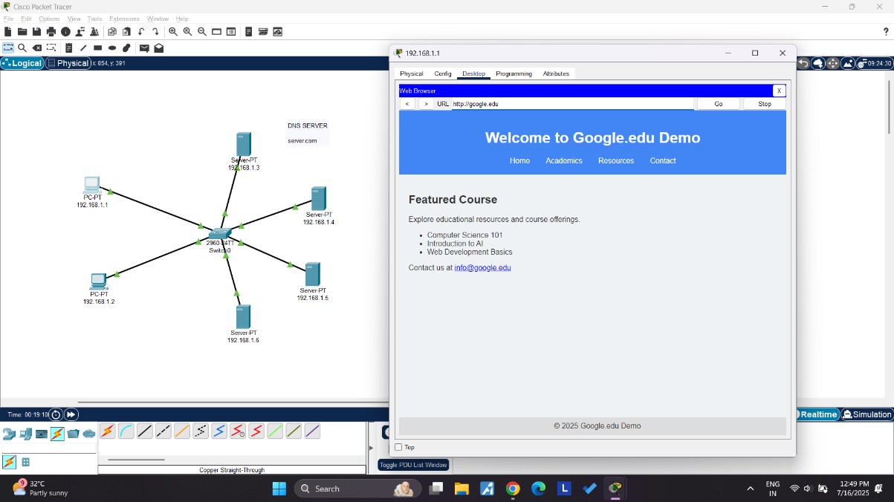
- DHCP
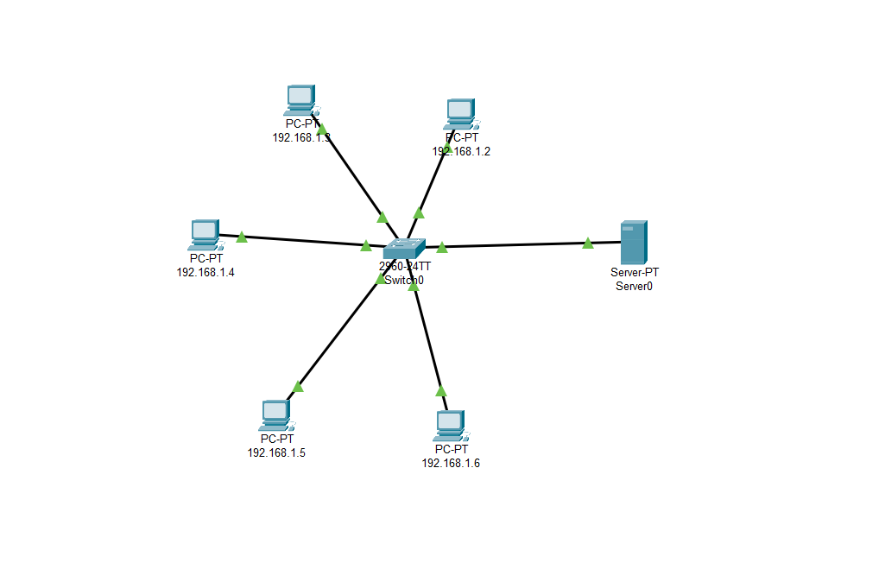
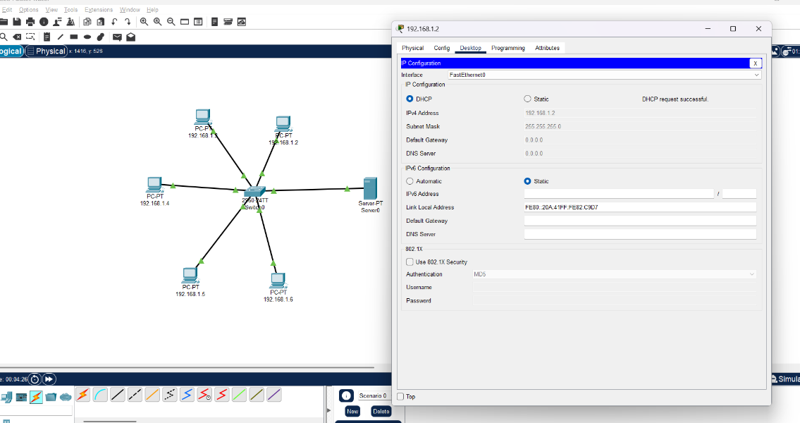

- FTP

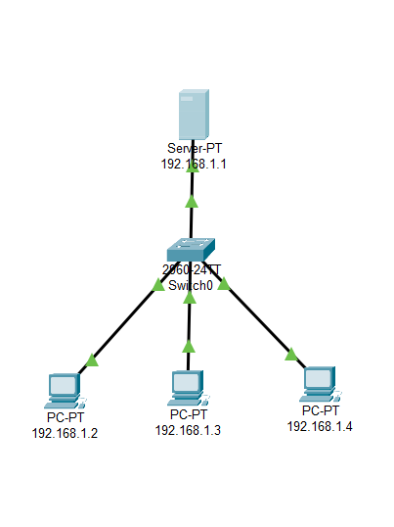

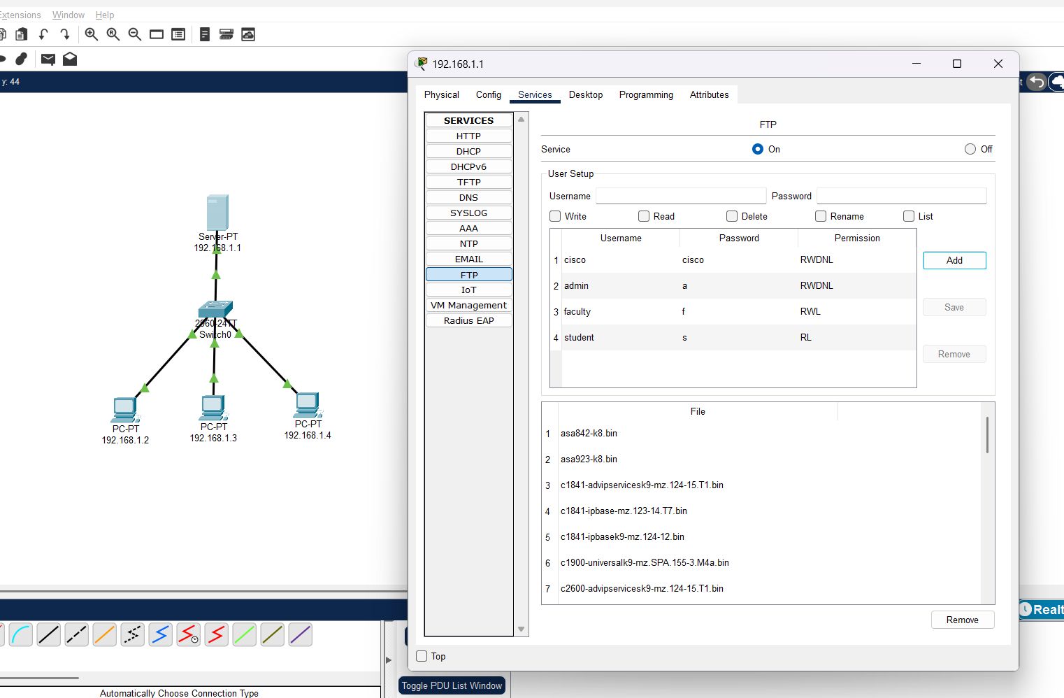
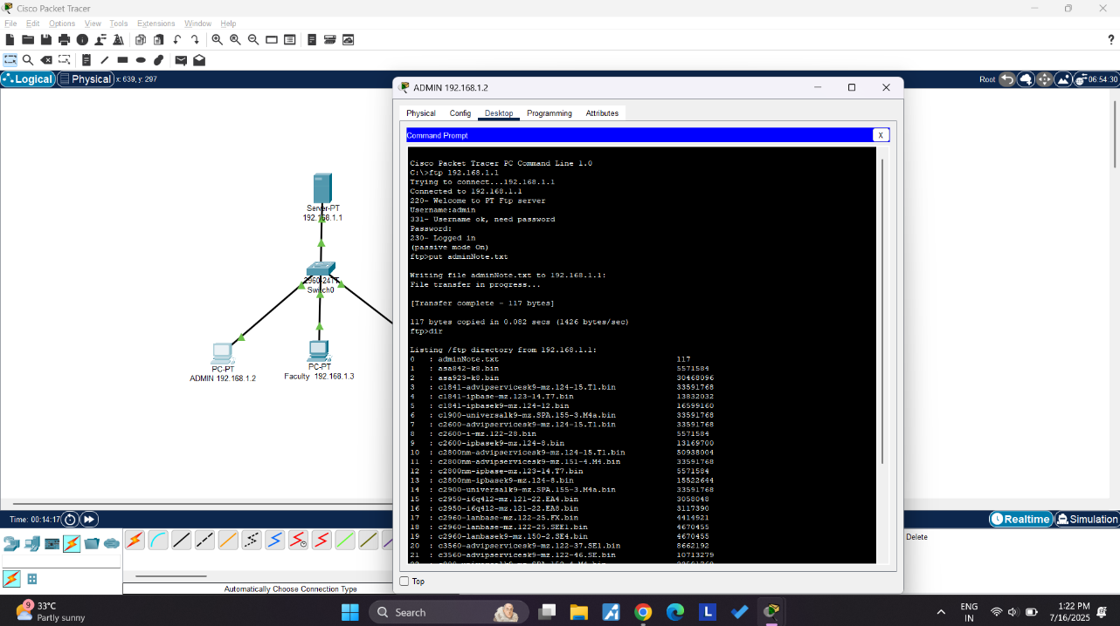
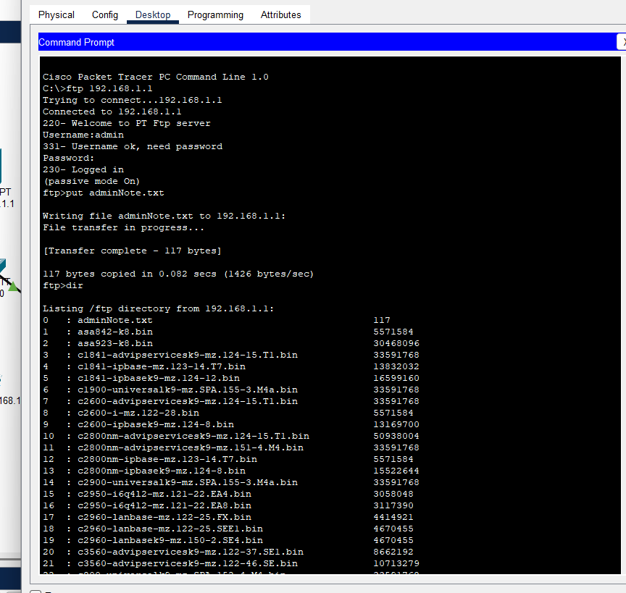

Instructions:
- Protocol-wise configuration setup screenshot.
- Mention IP address of each pc as label.
- Ping command or PDU screenshot between two pcs.

